**Papers written by**

**Australian Maths Software**

**REVISION 3**

**2016**

**SEMESTER 2**

**MATHEMATICS**

**APPLICATIONS**

**Units 1 & 2**

**SOLUTIONS**

**SECTION 1 – Calculator-free**

**Question 1** (**5 marks)**

[](http://enlivenorganics.com/images/detailed/1/frozen_blueberries_05.jpg)(a) 



✓

✓

✓

The 125 grams for $4.90 is the cheaper

(b)  ✓



Holly will get $7000 a month next year. ✓

**Question 2 (5 marks)**

(a)  ✓ ✓

(b)  ✓

(c)  cannot be calculated as the matrices are not the same size. ✓✓

**Question 3 (8 marks)**

(a) (i) $300 x 4 = $1 200 ✓

(ii) $300 x 10 = $3 000 ✓

Profit = $3 000 – $900 = $2100 ✓

(iii) 

(b) 



✓

✓

✓

**Question 4 (13 marks)**

(a) (i)  ✓✓

(ii)

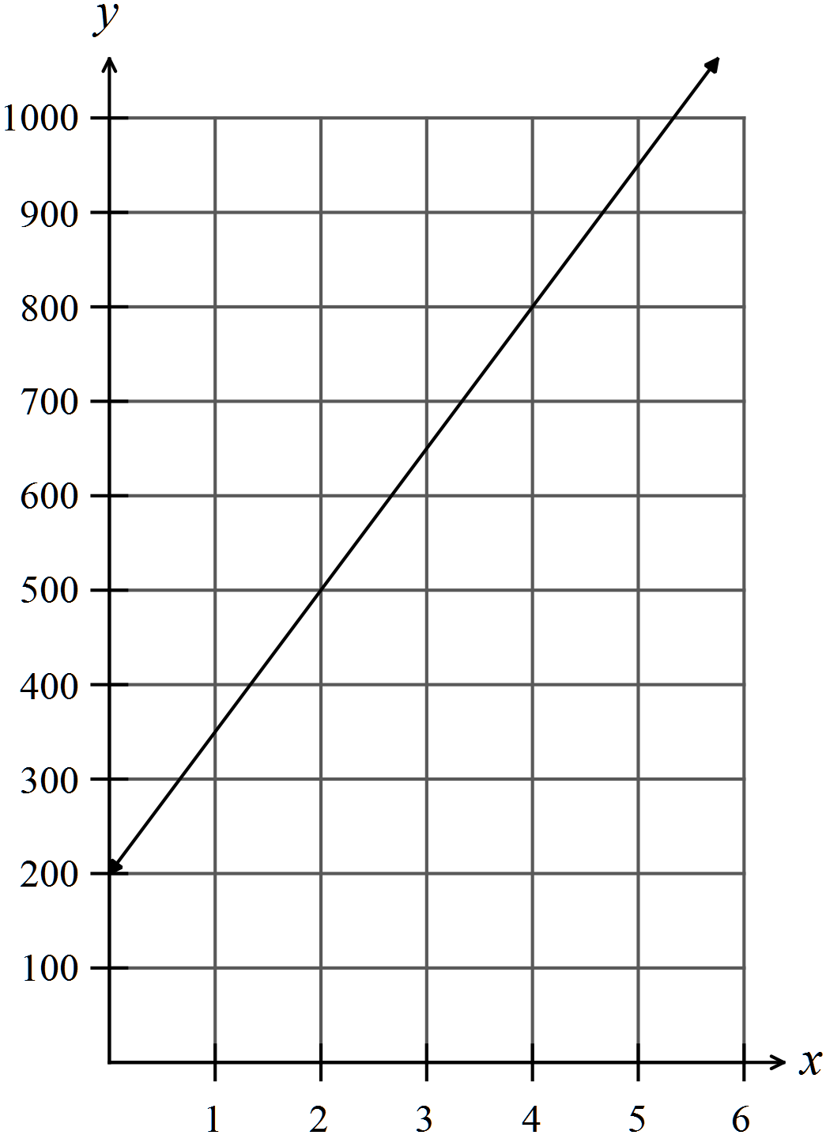 ✓✓

(iii)  ✓✓

(iv)

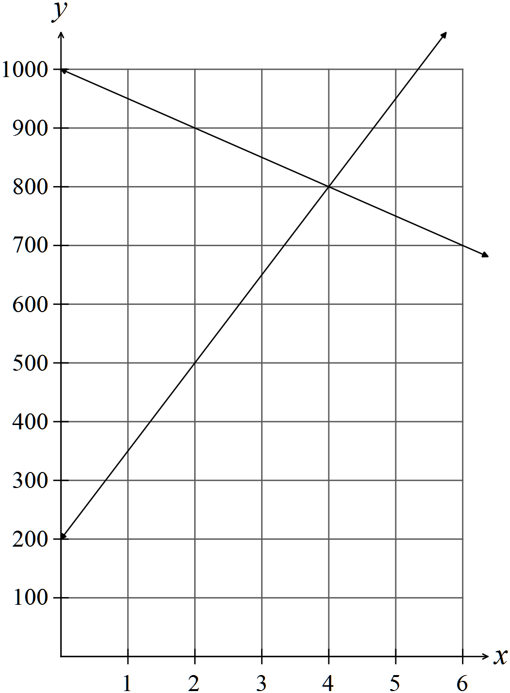 ✓✓

(v) After 4 weeks. ✓

✓

(vi) 

✓

(b) 

✓



✓

**Question 5 (9 marks)**

✓

(a) 

✓

✓

✓✓

(b)

✓

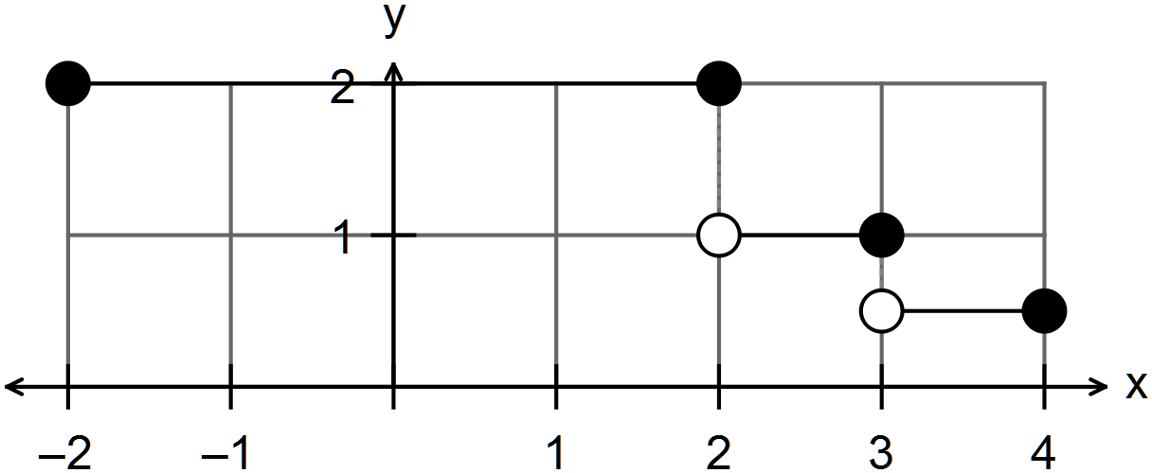

✓ inequalities

✓

✓

**Question 6 (12 marks)**

(a) (i) “Educational level” is ordinal as you can rank education according to the number of

years. ✓✓

(ii) The “number of pets in a family” is discrete as the number of pets is a counting

number. ✓✓

(iii)

✓✓

1

3

(b) (i)  ✓

 ✓

(ii) 101 ✓

(iii) The distribution is very tightly clustered.

The data is skewed to the right with the mode being the minimum score.

✓✓✓

**END OF SECTION ONE**

**SECTION 2 – Calculator-assumed**

**Question 7 (6 marks)**

(a)

 ✓✓ -1/error

(b)  ✓✓ -1/error

(c) Ranking scores (sum of the rows):

✓

|  |  |
| --- | --- |
| ***P*** | 5 |
| ***Q*** | 2 |
| ***R*** | 3 |
| ***S*** | 4 |

The ranking of the teams from first to last is  ✓

**Question 8 (11 marks)**

(a) (i)  ✓

(ii) $87.99 x 52 = $4575.48 ✓✓

(iii) $20990 – 52 x $50 = $18 390 ✓

(iv)  i.e. 12.4% depreciation. ✓✓

(b) (i) 

✓ ✓

(ii) Profit $16 ✓

Profit % = 

✓ ✓

**Question 9 (11 marks)**

(a) (i) 

✓

✓

(ii) 

✓

✓

(iii)

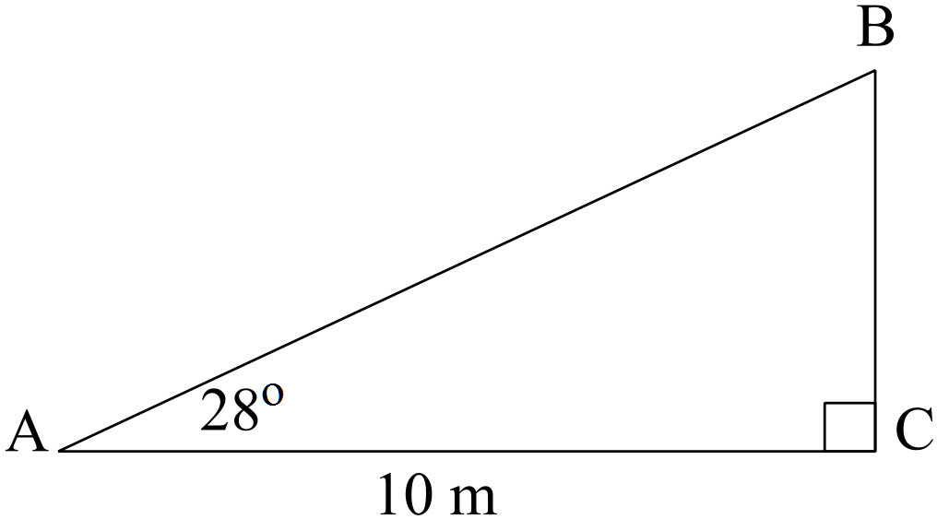



✓

✓

✓

(b)

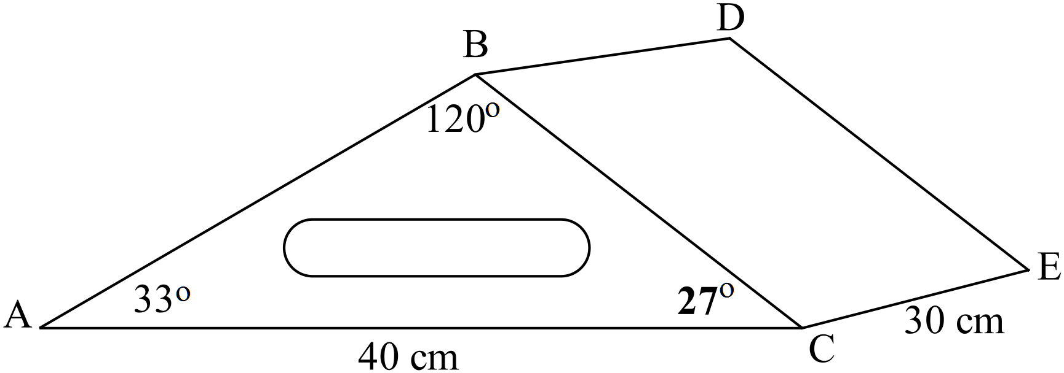

(i) 



✓

✓

(ii)  ✓

(iii) Volume = area of end x length

 ✓

**Question 10 (9 marks)**

(a)

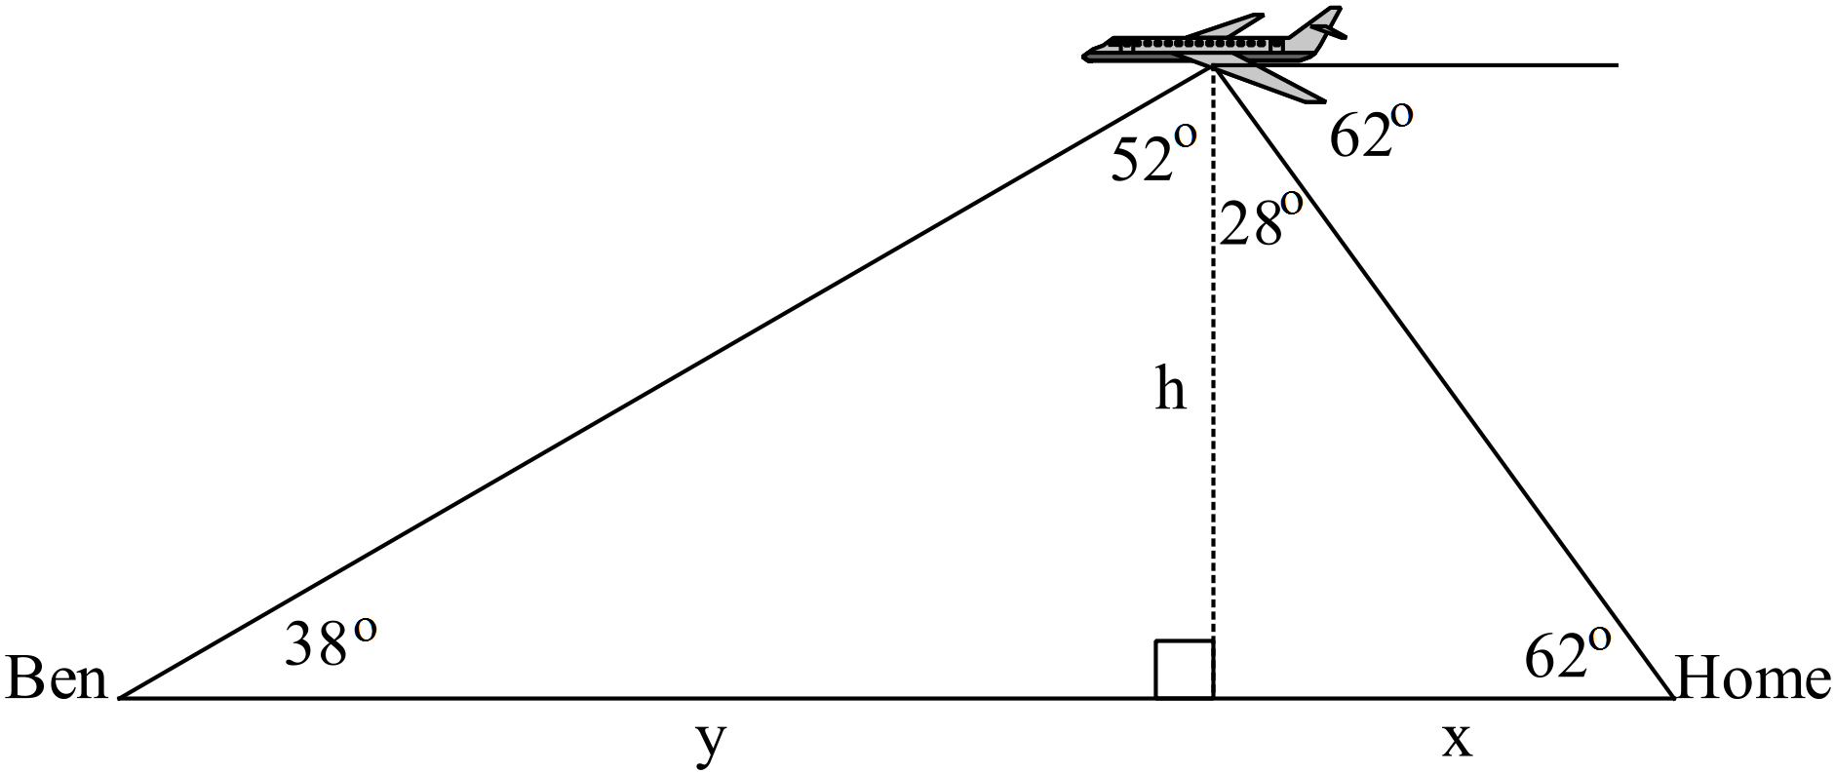



✓

✓

✓

✓

The plane is approximately 3000 metres above the ground.

(b) (i)

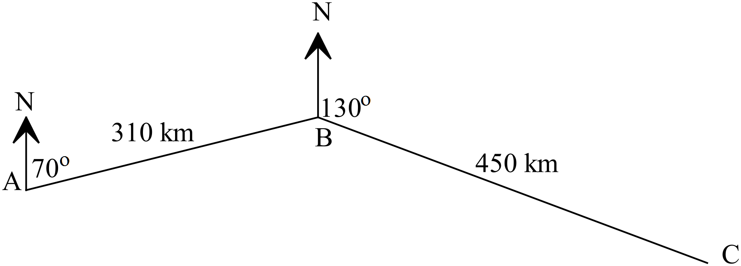

✓

✓

(ii)

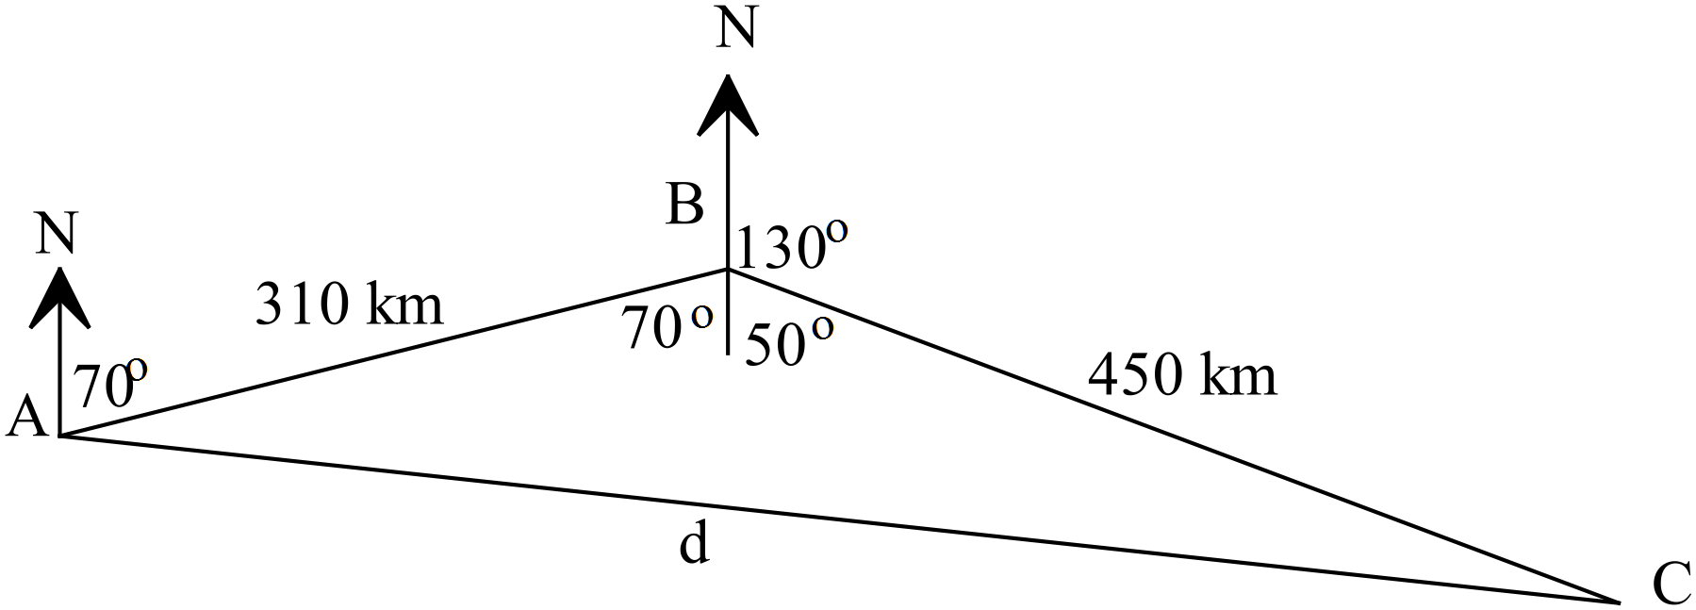

✓



✓

✓

The plane is 662 km from Perth

**Question 11 (5 marks)**

(a) 

✓

The multiplying linear factor is 15.

Weight = 

✓

✓

(b) 

✓

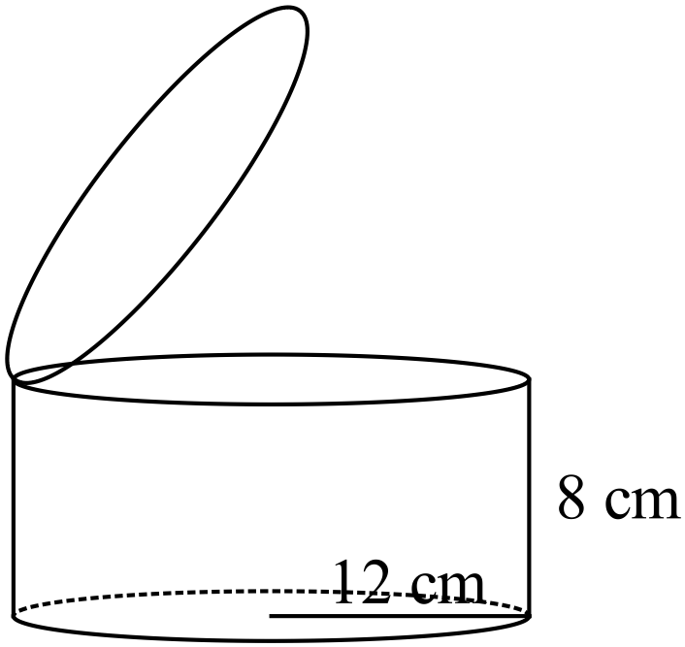 

✓

**Question 12 (7 marks)**

(a) 

✓



✓

✓✓

✓

(b) 

✓



✓

**Question 13 (8 marks)**

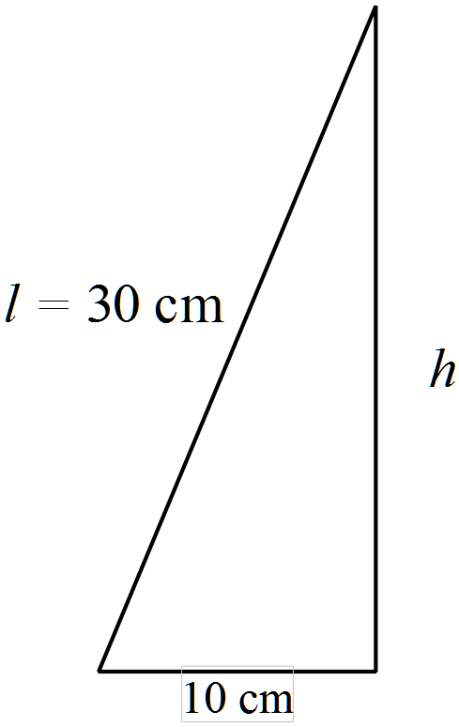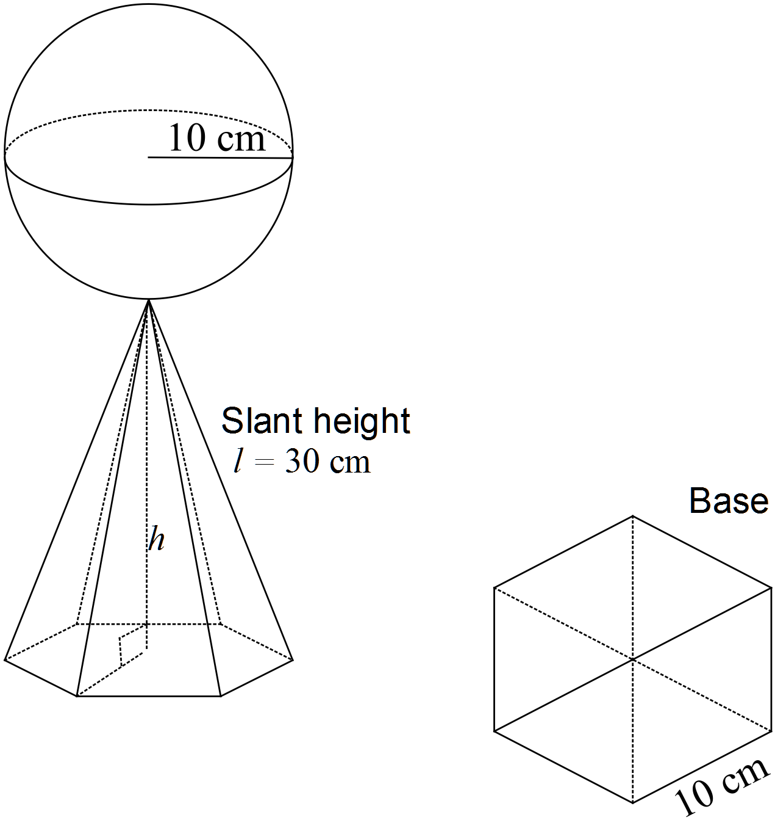

(a) 

✓



✓

(b) 

✓

✓✓

(c) 

✓✓



✓

**Question 14 (4 marks)**

Let x be the price of a dozen eggs.

Let y be the price of a loaf of bread.

✓





✓

✓

✓

Therefore a dozen eggs costs $4 and a loaf of bread costs $2.30

**Question 15 (13 marks)**

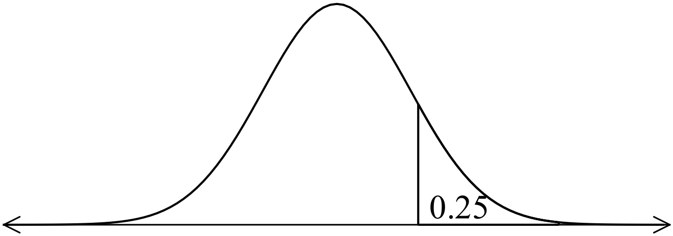 (a) (i) 0.9332 ✓✓

(ii) 0.8413 ✓✓

(iii) 0.6692 ✓✓

(iv) 76 ✓✓

(b) Maths z = 2 70+2(10) = 90% ✓✓

English z = 0 75% ✓

PE z = -1.96 80%- 1.96 x 15 = 50.6% ✓✓

**Question 16 (17 marks)**

(a) (i) Range = 7 – 1 = 6 ✓

IQR = 4.5 – 2.5 = 2 ✓✓

(ii) It will change the maximum to 10 as the end point is now 10. ✓

It changes the range from 6 to 9. ✓

(iii) Q1 changes from 2.5 to 3 ✓

IQR changes to 4.5 – 3 =1.5 ✓

(iv) The median changes from 4 to 3 ✓✓

(v) Each point will increase by 2 so the range goes from 3 to 9 but remains at 7.

The IQR will remain the same. ✓

All other measures, Q1, Q2, Q3, max, min will increase by 2. ✓

(vi) Set 1

Set 2

Both sets have a median of 4. ✓

Set 1 Range = 7 – 1 = 6 IQR = 4.5 – 2.5 = 2

Set 2 Range = 5 – 1 = 4 IQR = 5 – 2 = 3

The middle 50% in Set 2 are more spread out than the highly clustered middle 50% of

Set 1, especially between Q2 and Q3. ✓

The top 50% is the same as the top 25% in Set 2, so the scores are clustered between 4 and 5. The data is skewed to the left. The maximum is the same as Q3. ✓

There may be outliers at either end of the data in Set 1. ✓

(b)  ✓

 ✓

**Question 17 (7 marks)**

(a)  ✓✓✓

(b)

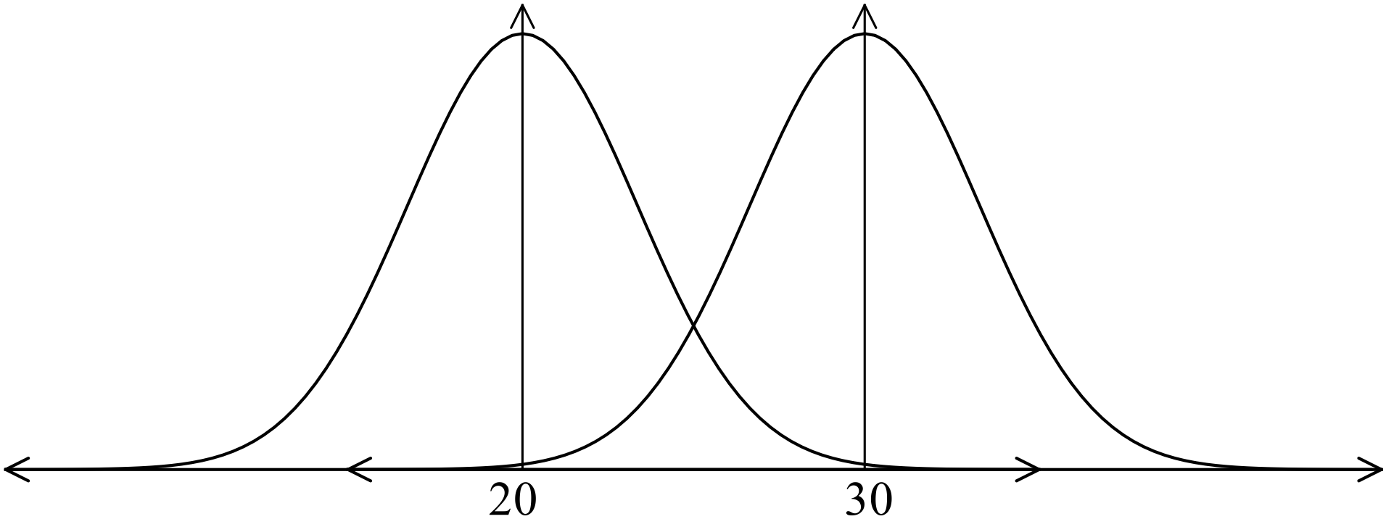 ✓✓✓✓

**End of solutions**